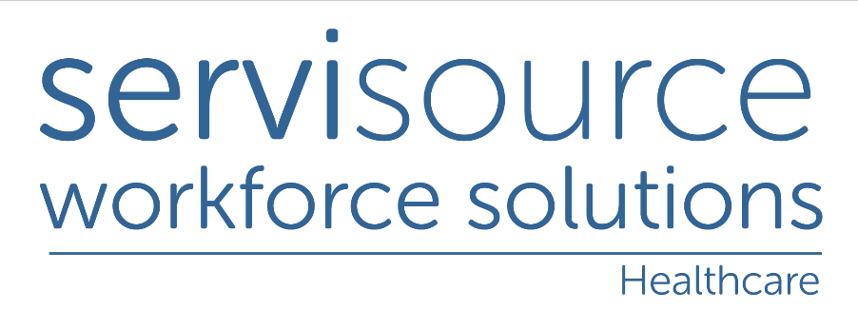
One temp per facility policy
Purpose and Scope
To minimise the transmission of Covid -19 and to maintain the safety of staff and persons supported through infection control best practice in all healthcare facilities.
Objective
To always adhere to public health guidelines to impact positively the safety of our temps and client facilities.
- Servisource temporary staff are Not permitted to work in more than one facility during the current pandemic
- All Servisource staff have signed a declaration form and this is saved to their file. The declaration form includes the following:
- They can only work in one facility at a time during the pandemic. A 10-day isolation period must be adhered to if a temp is taking up work in a different facility.
- They must notify us if they have symptoms and self-isolate for the required 10 days
- If a temp identifies as a Close Contact, they must self-isolate for the required 10 days.
Further information about COVID-19 and what to do if you think you may have symptoms can be found here
Responsibilities

In the event of a positive case of COVID-19 for any agency staff such workers cannot return to the workplace following:

- An incidence of COVID-19 self-isolation/illness unless authorised to do so.
- If symptomatic you do not present to the workplace as per Public Health advice.
- In addition, it is important that cross-contamination is avoided in as much as possible. To safeguard against this, consistent staffing cover with the same candidates working across the same services on an ongoing basis is preferential thus minimising risks to all front-line staff.
- Working across a multiple range of sectors/locations at this current time is not best practice based on the current pandemic situation and required health safety measures as a result.
- Infection control is vital to ensure the safety and welfare of everyone
This document is incorporated into Servisource/MyHomecare Covid-19 procedure 180121

